Wildfire and Smoke Season
-Manuel Mose, Tribal Planner, Emergency Manager (05/26/2023)

(Use the camera function on your smartphone to access the QR codes. If the links do not work, type the address in on your phone, tablet, laptop, or desktop.)
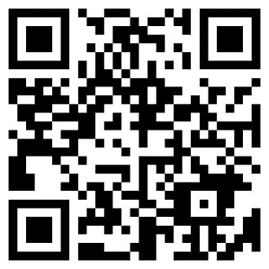
QR Code for https://www.airnow.gov/wildfires/be-smoke-ready/
Air Now “Be Smoke Ready” message.
Plan Ahead: Stock up; Give yourself more time; Talk with Healthcare Provider; Prepare.

If you live in an area where the wildfire risk is high, take steps now to prepare for fire season. Being prepared for fire season is especially important for the health of children, older adults, and people with heart or lung disease.

For More information:
- Get air quality information: Check your local news, the www.airnow.gov website, or your state air quality agency’s website.
- Learn about home air cleaners: https://www.epa.gov/indoor-air-quality-iaq/guide-air-cleaners-home-0
- Find certified air cleaning devices: http://www.arb.ca.gov/research/indoor/aircleaners/certif ed.htm
- Learn how to use an N95 respirator mask: http://www.bepreparedcalifornia.ca.gov/Documents/Protect%20Your%20Lungs%20Respirator.pdf
- Learn more about wildfire smoke: How Smoke from Fires Can Affect Your Health: https://www.airnow.gov/airquality-and-health/how-smoke-from-fires-can-affect-your-health

Wildfire Smoke Factsheet: Prepare for Fire Season:
https://www.airnow.gov/sites/default/files/2021-07/prepare-for-fire-season.pdf

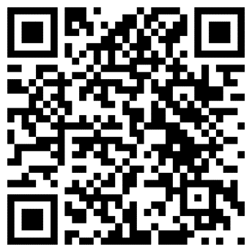
QR Code: Burns, OR Air Quality Status from www.Airnow.gov

What is AirNow?
AirNow is a partnership of the U.S. Environmental Protection Agency, National Oceanic and Atmospheric Administration (NOAA), National Park Service, NASA, Centers for Disease Control, and tribal, state, and local air quality agencies. Complete list of AirNow partners. Agencies all over the country send their monitoring data to AirNow for display. The Department of State provides data from U.S. Embassies and Consulates to inform personnel and citizens overseas, and the U.S. Forest Service and NOAA provide fire and smoke data.

Other Resources:
Fire Adapted Communities Learning Network: https://fireadaptednetwork.org/
The National Association of County Health Officials: https://www.naccho.org/blog/articles/smoke-sense-app-alerts-public-about-wildland-fire-smoke-risks

